
COMSATS University Islamabad (CUI)

Software Requirement Specification
(SRS DOCUMENT)
for
Stock Logistics

Version 1.0

By
Waqas Ahmad CIIT/FA19-BCS-087/ISB
Ahmed Habib Pandit CIIT/FA19-BCS-094/ISB

Supervisor
Mr. Asif Muhammad

Bachelor of Science in Computer Science (2019-2023)

Revision History
Name | Date | Reason for Changes | Version

Application Evaluation History
Comments (by committee)  *Include the ones given at scope time both in doc and presentation | Action Taken

Supervised by
Mr. Asif Muhammad

Signature______________

Table of Contents

1 Introduction 5
1.1. Purpose 5
1.2. Scope 5
1.3. Module 5
1.4. Overview 6
2 Overall Description 6
2.1. Product Perspective 6
2.2. Context Diagram 7
2.3. User classes and characteristics 8
2.4. Operating Environment 8
2.5. Design and Implementation Constraints 8
3 Requirement Identifying Technique 9
4 Functional Requirements 61
4.1. UC-1: Sign up 61
5 Non-Functional Requirements 94
6 External Interface Requirements 95
6.1 User Interfaces Requirements 95
6.2. Software interfaces 95
6.3. Hardware interfaces 95
6.4. Communications interfaces 95
7 References 96
8 Plagiarism Report 96

Introduction

Purpose

The System Requirements Specification (SRS) for Stock Logistics aims to provide the readers information about the system functions and specifications. SRS describes the data, functional and behavioral requirements of the software and is intended for participants that are making this project, Supervisor, and Project Evaluation Committee.

Scope

This project aims to provide a platform for small businesses storing, shipping, and selling solution to maintain good service and fast shipping. It’s based on the concept of distributed warehouse networks where any person with space can open a warehouse to accommodate a business inventory. Warehouses will also be required to ship the business inventory to the required customers. Warehouse will be able to sell their own inventory to customers along with other services. Stock Logistics also provide the opportunity for the people to have space and are looking to earn profit from it.

A Seller will be able to source product and will send it to warehouse. Seller can register with multiple warehouses so that their inventory will be able to wide range of customers. After selecting the warehouse, the Seller can source the product and our system will keep track of all the inventory. Now, it will be the responsibility of warehouse management to store, ship according to requirements of Seller. Warehouse can have multiple Sellers and it will be the responsibility of warehouse manager to keep track of the Seller inventory. Store logistics will manage all the activities and will charge 10% of revenue and $40 per month. Store logistics will recommend products to buyers. System will analyze data and will recommend warehouse managers to open a new branch in a specific area depending on order traffic.

Module
- Account Management
- Inventory Management
- Warehouse Management
- Order Handling
- Buyer Management
- Payments & Sales
- Dispute Management
- Data Analysis & Recommendations
- Chat

Overview

This System Requirements Specification will be able to provide the reader of the document an overall description of the system. It will be able to provide a product perspective to the system the type of user that will use the system, and the operating environment of the system. It will also specify the design and implementation constraints of the system. Furthermore, use case will be used as a requirement identifying technique and listed in tabular form. Use case diagram for each module will also be shown. Functional requirements of each use case will be listed to give us a clear idea about the requirements of a use case. The document will list out the Nonfunctional requirements. The document will also list out the any external interface requirements that are needed to run the system.

Overall Description

Stock Logistics aims to provide a platform for small businesses storing, shipping, and selling solution to maintain good service and fast shipping. It’s based on the concept of distributed warehouse networks where any person with space can open a warehouse to accommodate a business inventory. Warehouses will also be required to ship the business inventory to the required customers. Warehouse will be able to sell their own inventory to customers along with other services. Stock Logistic also provide the opportunity for the people to have space and are looking to earn profit from it.

Product Perspective

Stock logistics is inspired by problems of storing, shipping, and selling for small business. It is based on different existing similar systems. Theses already existing products have major shortcomings like reliability, accurate recommendations and buying and selling product in bulk. Stock logistics is better solution to same problems by providing a platform for small businesses storing, shipping, and selling solution to maintain good service and fast shipping. It’s based on the concept of distributed warehouse networks where any person with space can open a warehouse to accommodate a business inventory. Also, for an average or a new company it would not be feasible to buy or rent out a warehouse in multiple places due to increase in the prices of labor, utilities, and housing. As a result, they cannot source the store their products in a timely manner and end up losing shelf space and money. An average household has empty space which is not being used.

Context Diagram

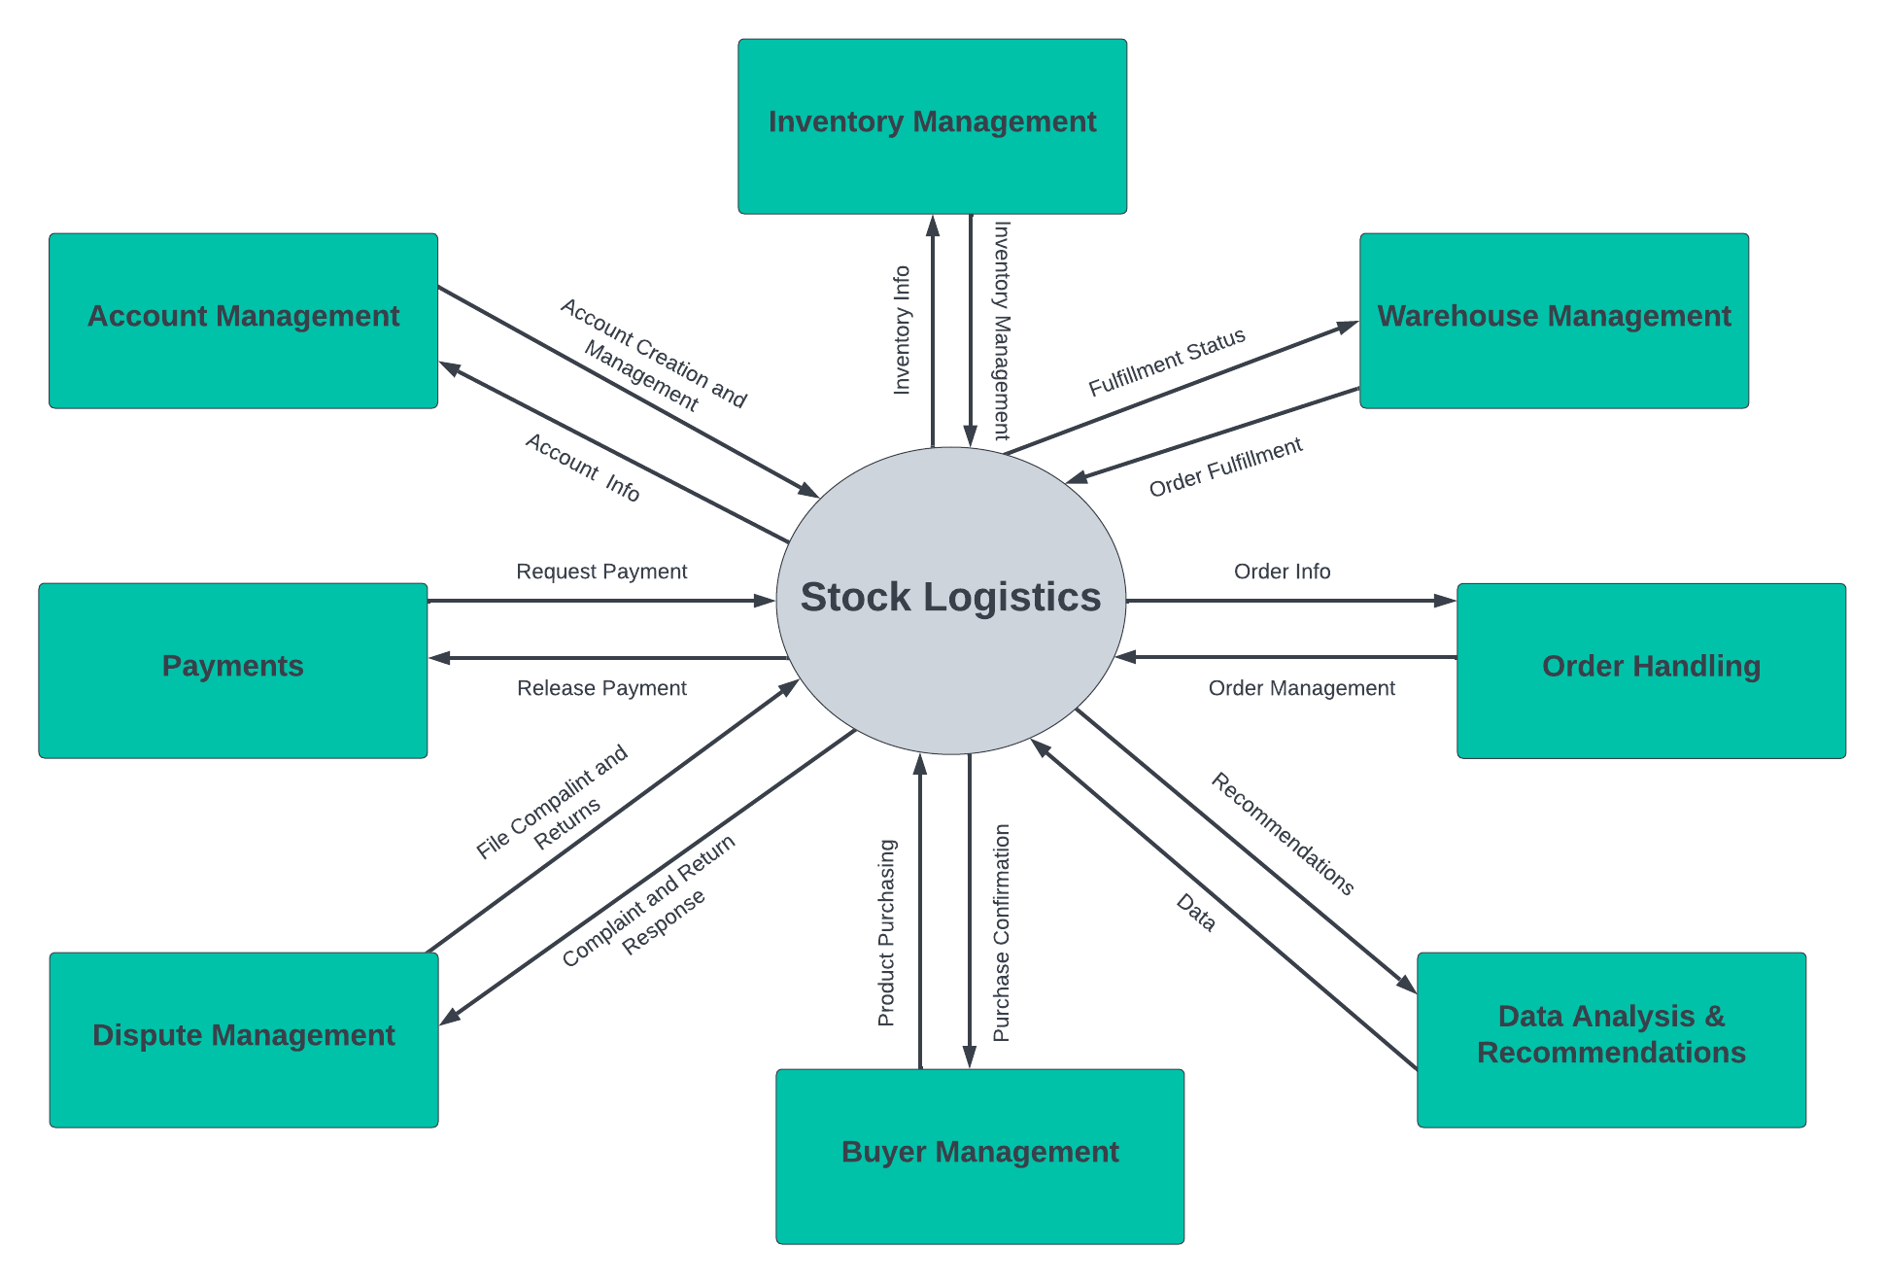

Figure 1: Context Diagram Stock Logistics

User classes and characteristics
This table shows user classes and characteristics.

Table 1: User Classes and Characteristics
User Class | Description
Admin | The admin will be the person who will manage Stock logistics platform for warehouse manager and buyers. Admin will manage all the payments, and charges and management measures.
Buyer | The buyer will be the person who will buyer products from warehouses.
Seller | The Seller will be the person who will source product and will sent it to warehouse. Seller can register with multiple warehouses so that their inventory will be available to wide range of customers. Seller will be able to sell products on Stock Logistics.
Warehouse Manager | The warehouse manager will be the person who will keep track of storage, shipping according to requirements of Sellers. Warehouse can have multiple Sellers and it will be the responsibility of warehouse manager to keep track of the Seller inventory.

Operating Environment

OE-1: Stock Logistic will be supported by all the operating systems which are supporting the web browsers.

OE-2: Web browser will be required for Stock Logistics. System will be able to run on any web browser.

OE-3: Stock Logistic system will work on any supported system, but the performance will depend on system resources.

Design and Implementation Constraints

CON-1: The Stock Logistic system shall use mongo dB database.

CON-2: The system will use react.js and node.js.

CON-3: The Stock Logistic system will use Visual Studio code as an integrated
development environment (IDE).

Requirement Identifying Technique

  - Use Case Diagrams

Module 1: Account Management

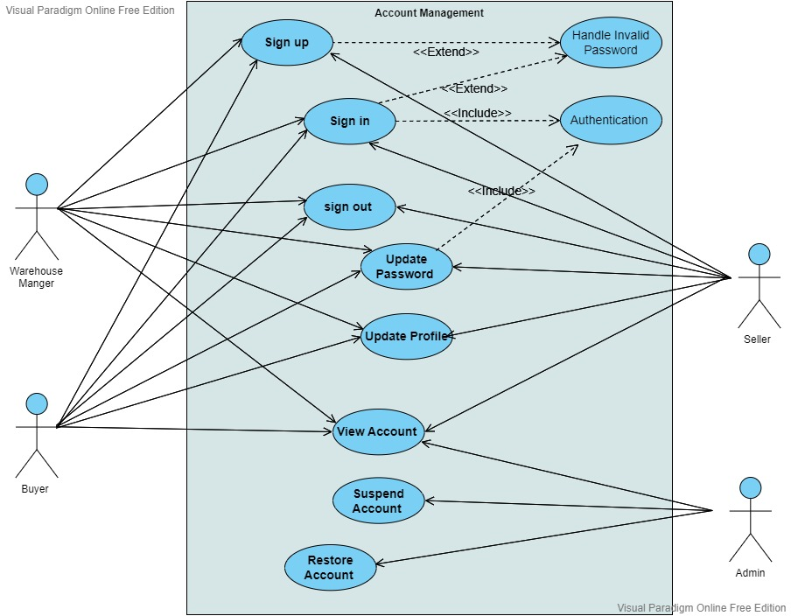

Figure 2: Use case diagram of Account Management

Module 2: Inventory Management
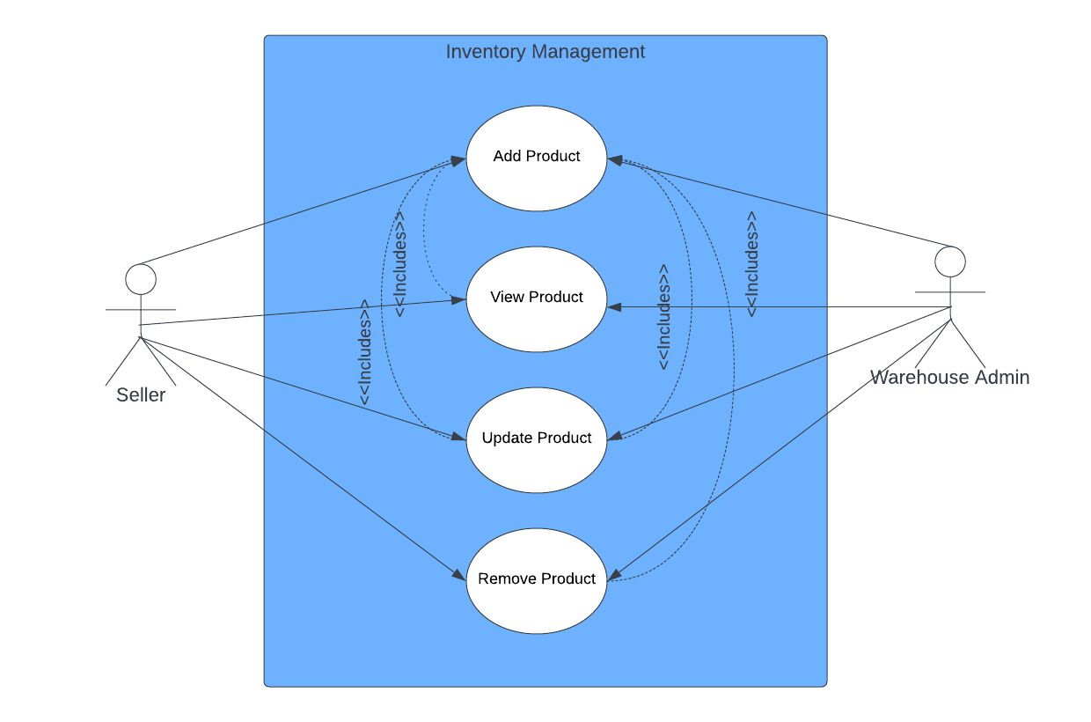

Figure 3: Use case diagram of Inventory Management

Module 3: Warehouse Management

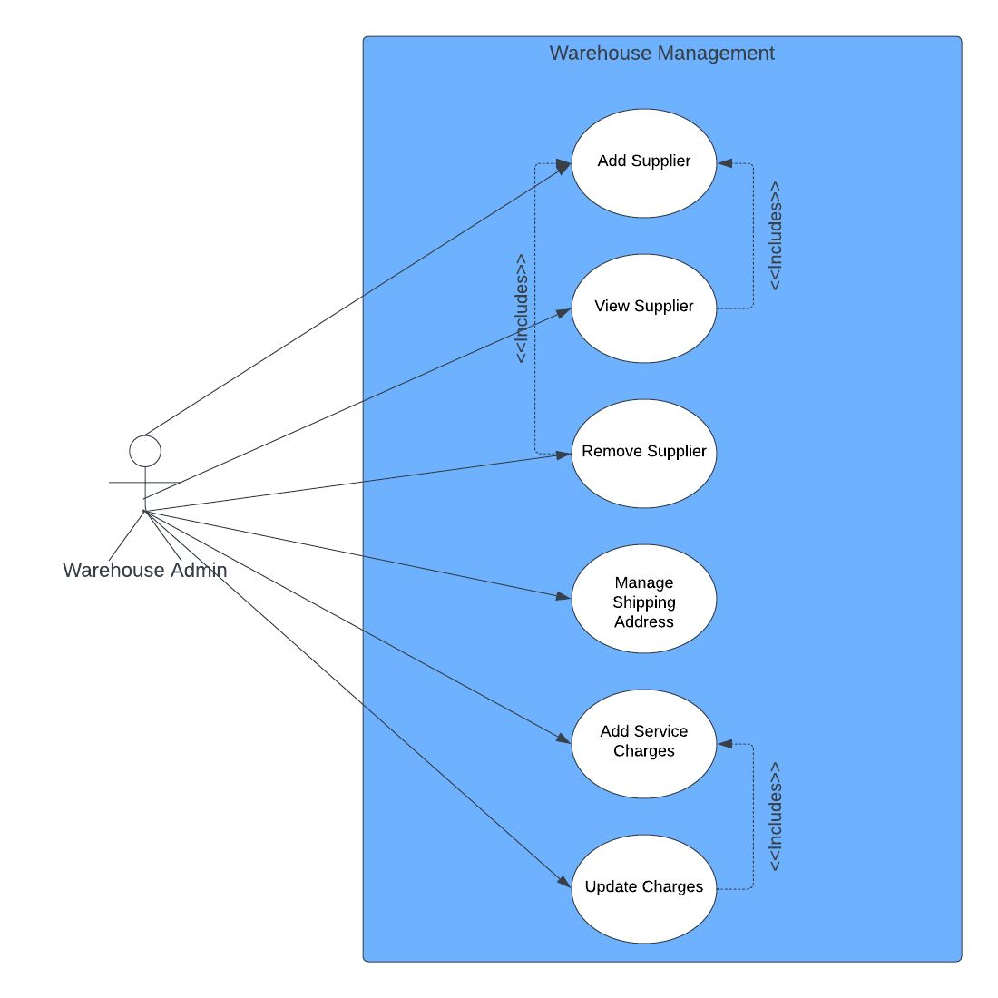

Figure 4: Use case diagram of Warehouse Management

Module 4: Order Handling

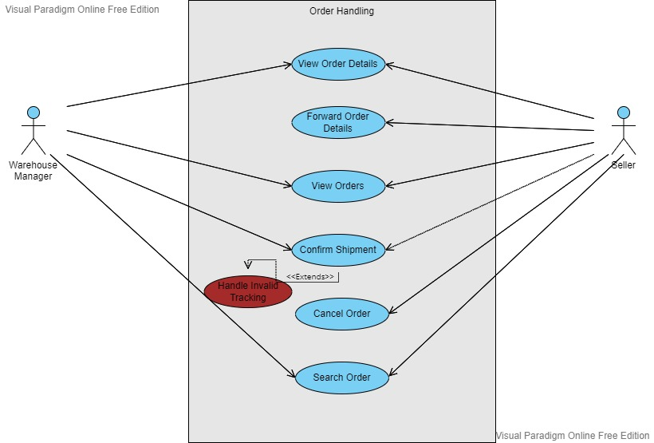

Figure 5: Use case diagram of Order Handling

Module 5: Buyer Management

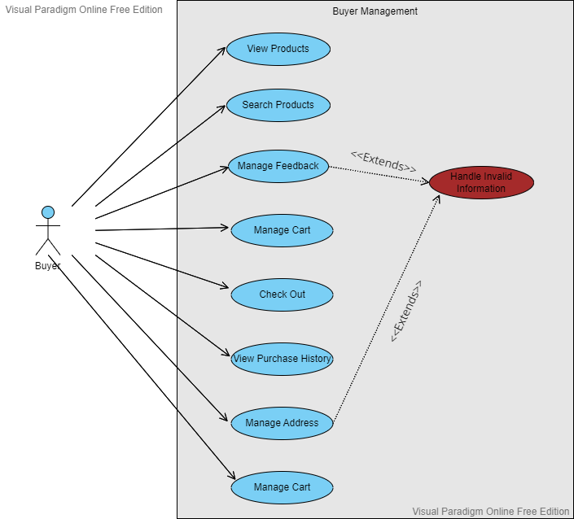

Figure 6: Use case diagram of Buyer Management

Module 6: Payments & sales

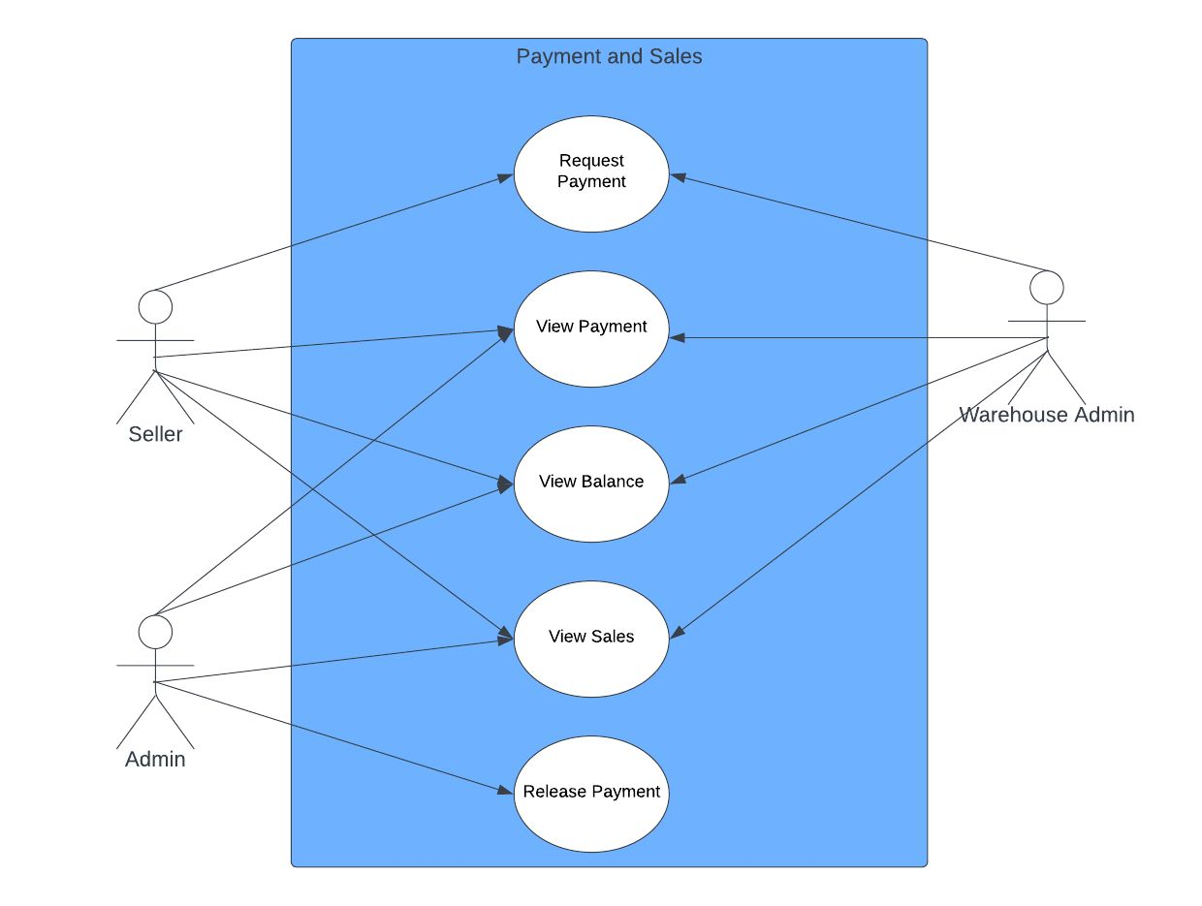

Figure 7: Use case diagram of Payments & sales

Module 8: Dispute Management
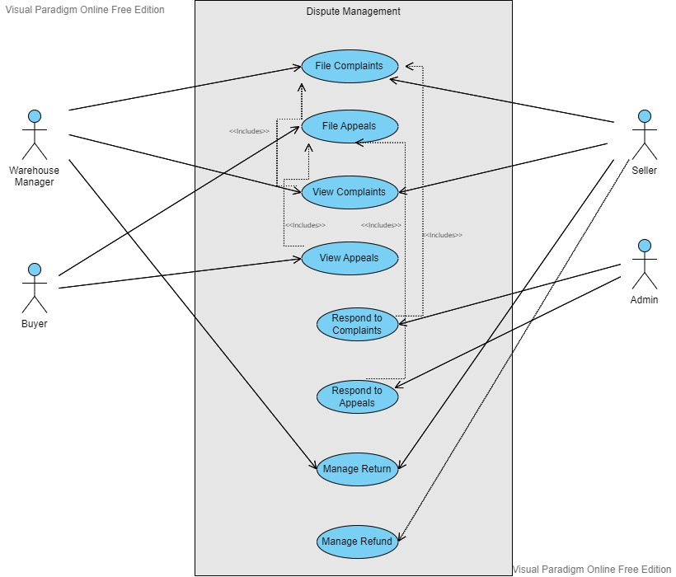

Figure 8: Use case diagram of Dispute Management

Module 7: Data Analysis & Recommendations
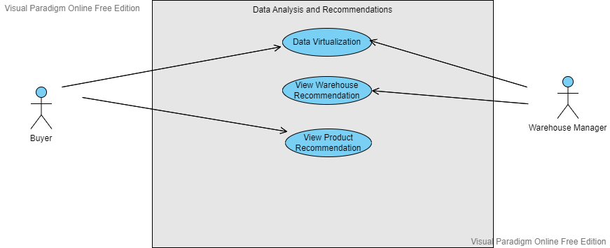

Figure 9: Use case diagram of Data Analysis & Recommendations

Module 9: Chat

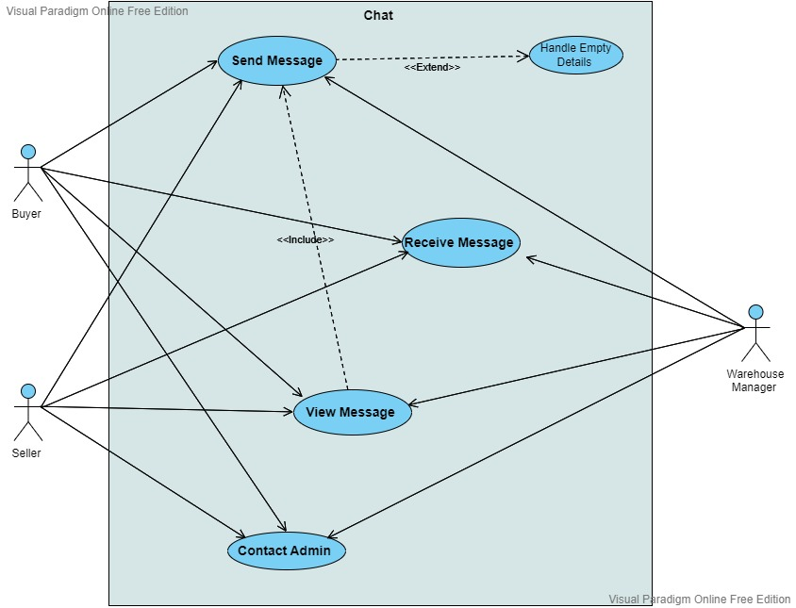

Figure 10: Use case diagram of Chat

  - Tabular Use Cases

Module 1: Account Management

UC-1: Sign up
In this use case user will be able to sign up to Stock Logistics. User will be able to sign up with valid required information like email and password. User of the systems are warehouse manager, Seller, buyer.
Table 2: Sign up
Actors | Primary Actors: Warehouse manager, Seller, Buyer
Trigger | User will click on “Sign up” button.
Preconditions | PRE-1. User must have required information.
Postconditions | POST-1. User will be registered to system  POST-2. User will be able to avail services of system.
Normal Flow | - User will start the system.  - System starts on login page.  - User will click on “sign up” button to register to system.  - Sign up page will open and contain text boxes and labels for various required fields.  - User will select the category like seller, buyer or warehouse manager.  - User will enter required details.  - User will press “Register” button.  - System will verify email address.  - Account will be created and activated.
Alternate Flow | None
Exceptions | - System will prompt user to empty fields.  - System will not allow user to create account without verification code.  - System will not allow to register to system without valid details.
Business Rules | None
Assumptions | User has required valid information.
UC-2: Sign in
In this use case user will be able to sign into system. User will be able to sign in with valid required information like email and password. User of the systems are warehouse manager, Seller, buyer.
Table 3: Sign in
Actors | Primary Actors: Warehouse manager, Seller, Buyer
Trigger | A user will click on “Sign in” button.
Preconditions | PRE-1. User must have required information.
Postconditions | POST-1. User will be prompt to home screen  POST-2. User will be able to avail services of system.
Normal Flow | - User will start system.  - System will start on login page.  - User will enter email address and password.  - User will click on sign in.  - System will authenticate information provided and give access to users if valid.  - System will prompt to home screen.
Alternate Flow | None
Exceptions | - System will prompt user to empty fields  - System will not allow to sign in with wrong email and password.
Business Rules | None
Assumptions | User has required valid information.

UC-3: Update Password
In this use case user will be able to reset/update password. User of the systems are warehouse manager, Seller, buyer.
Table 4: Update Password
Actors | Primary Actors: Warehouse manager, Seller, Buyer
Trigger | A user will click on “Reset Password” button.
Preconditions | PRE-1. User must have email access for verification.
Postconditions | POST-1. Password will be updated for next time.  POST-2. User will be able to login with new password.
Normal Flow | - User will click on “Forgot password” button  - User will enter registered email address.  - System will validate email address.  - User will enter new password  - User clicks confirm.  - Password will be updated
Alternate Flow | None
Exceptions | - System will prompt user to empty fields  - System will not allow to update password without email validation.  - System will generate exception on weak password.
Business Rules | None
Assumptions | User has access to registered email address.

UC-4: Sign Out
In this use case user will be able to sign out/logout from system. User of the systems are warehouse manager, Seller, buyer.
Table 5: Sign out
Actors | Primary Actors: Warehouse manager, Seller, Buyer
Trigger | A user will click on “Sign out” button.
Preconditions | PRE-1. User is logged into system.
Postconditions | POST-1. System will prompt to login screen.
Normal Flow | - User will click on sign out button.
Alternate Flow | None
Exceptions | None
Business Rules | None
Assumptions | None

UC-5: View Account
In this use case user will be able to view profile, account setting, states and all the details of account. User will be Admin, Warehouse manager, Buyer and Seller.
Table 6: View Account
Actors | Primary Actors: Admin, Warehouse manager, Seller, Buyer
Trigger | User will click on “My Account” button.
Preconditions | PRE-1. User is logged into system.  PRE-1. User must have access to particular details.
Postconditions | POST-1. User will be able to view account details.
Normal Flow | - User will click on “My Account”.  - User will be able to view details.  - User will be able to click on personal details, account details.
Alternate Flow | - User will click on profile.  - User will be able to view account details.
Exceptions | None
Business Rules | None
Assumptions | User is logged into system.
UC-6: Update Profile
In this use case user will be able to update profile. User will be able to update personal details, business details. Users will be Warehouse manager, Buyer and Seller.
Table 7: Update Profile
Actors | Primary Actor: Warehouse manager, Seller, Buyer
Trigger | A user will click on “Edit Profile” button.
Preconditions | PRE-1. User is logged into system.
Postconditions | POST-1. User will be able to edit profile.
Normal Flow | - System will start from home page.  - User will click on profile button.  - User will click on edit profile option.  - User will enter new details of account.  - User will click on Save button to commit changes.  - User Profile will be updated accordingly.
Alternate Flow | None
Exceptions | - System will not allow user to update invalid details  - System will prompt to empty fields.
Business Rules | None
Assumptions | User is logged into system.

UC-7: Suspend Account
In this use case Admin will be able to suspend a users’ account on any policy violation. Admin may suspend some of privileges or whole account.
Table 8: Suspend Account
Actors | Primary Actor: Admin
Trigger | Admin will click on “Suspend Account” button.
Preconditions | None
Postconditions | POST-1. User account will be suspended.
Normal Flow | - Admin will press the Manage Account Button  - Account Page will open where all the account of users will be shown.  - Admin can search and click on an account to view and manage it.  - Admin will set user privileges.  - Admin will then click on suspend Account.
Alternate Flow | None
Exceptions | None
Business Rules | None
Assumptions | Admin must be authentic user of admin panel.

UC-8: Reactivate Account
In this use case Admin will be able to reactivate a suspended account of user.
Table 9: Reactivate Account
Actors | Primary Actor: Admin
Trigger | A user will click on “Activate Account” button.
Preconditions | None
Postconditions | POST-1. Account will be reactivated for services.
Normal Flow | - Admin will press the Manage Account Button  - Account Page will open where all the account of users will be shown.  - Admin can search and click on an account to view suspended accounts.  - Admin will set user privileges to reactivate.  - Admin will then click on Activate Account.
Alternate Flow | None
Exceptions | None
Business Rules | None
Assumptions | Admin must be authentic user of admin panel.

Module 2: Inventory Management

UC-9: Add Product
In this use case a seller and warehouse manager will be able to add inventory. The product will be available to customers after adding it to inventory list. The seller will list product for customers. While the warehouse manager will manage inventory of seller for shipping.

Table 10: Add Product
Actors | Primary Actors: Seller, Warehouse Manager
Trigger | Seller will click on “Add Product” button.
Preconditions | PRE-1. Seller is logged into system.  PRE-2. Seller must have selling privileges.
Postconditions | POST-1. Product is added to the inventory list.  POST-2. Product is available for customers  POST-3. Remaining quantity will be updated on each purchase.
Normal Flow | - Seller will click on “Manage Inventory”.  - Seller will click on “Add Product”.  - Seller will give required detail.  - Seller will add product.  - Product will be added to inventory.
Alternate Flow | None
Exceptions | - System will not allow Seller to add product if don’t have privileges.  - System will prompt to required empty fields.
Business Rules | None
Assumptions | Seller has privileges for selling and shipping.

UC-10: Remove Product
In this use case a seller will be able to removes a product from inventory. The product will not be available to customers after removing from inventory.
Table 11: Remove Product
Actors | Primary Actor: Seller, Warehouse Manager
Trigger | Seller will click on “Remove Product” button.
Preconditions | PRE-1. Seller is logged into system.
Postconditions | POST-1. Product is removed to the inventory list.  POST-2. Product will not be available for customers  POST-3. Customers will not be able to view.
Normal Flow | - Seller will click on “Manage Inventory”.  - Seller will click on “Remove Product”.  - Seller will select product from inventory list.  - Seller will click on remove.  - Product will click on “Delete listing”.  - Product will be removed from inventory.
Alternate Flow | None
Exceptions | None
Business Rules | None
Assumptions | None

UC-11: Update Product
In this use case a Seller will be able to update product. The product will be available to customers after updating with new details. Seller will be able to update price, title, handling time and other important details.

Table 12: Update Product
Actors | Primary Actors: Seller, Warehouse Manager
Trigger | Seller will click on “Update Product” button.
Preconditions | PRE-1: Seller is logged into system.  PRE-2. Seller must have selling privileges.
Postconditions | POST-1. Product is updated.  POST-2. Product is available with updated detail.  POST-3. Product is available for customers.
Normal Flow | - Seller will click on “Manage Inventory”.  - Seller will select the product to update.  - Seller will click on “Update Details”.  - Seller will update details.  - Seller will confirm updates.  - Product will be updated to inventory.
Alternate Flow | None
Exceptions | - System will not allow warehouse manager to update product if don’t have privileges.  - System will prompt to required empty fields.
Business Rules | None
Assumptions | Seller has privileges for selling and shipping.

UC-11: View Product
In this use case a user will be able to update product. Seller and buyer can view products. Warehouse manager can only view products that are registered with warehouse.

Table 13: Update Product
Actors | Primary Actors: Buyer, Seller, Warehouse Manager
Trigger | Seller will click on “View Products” button.
Preconditions | PRE-1: Seller is logged into system.  PRE-2. Seller must have selling privileges.
Postconditions | POST-1. Product is displayed.
Normal Flow | - User will click on “Manage Inventory”.  - User will click on product to view it.  - User will click on “View Details”.  - Details will be available to user.  - Seller can click on “Manage Inventory”.  - Seller will click on “View Products”  - All the listed products will be available to seller.
Alternate Flow | None
Exceptions | - System will not show any product if no product available.
Business Rules | None
Assumptions | User has account.

UC-12: Manage Price
In this use case a Seller will be able to update price of product. The product will be available to customers with new price. Seller will be able to update price.

Table 14: Manage price
Actors | Primary Actors: Seller, Warehouse Manager
Trigger | Seller will click on “Estimated Price” button.
Preconditions | PRE-1. Seller is logged into system.  PRE-2. Seller must have selling privileges.
Postconditions | POST-1. The price of product is updated.  POST-2. Product is available with new price.  POST-3. Product is available with new details.
Normal Flow | - Seller will click on “Manage Inventory”.  - Seller will select the specific product from inventory list.  - Seller will click on “Estimated price”.  - Seller will be able set price  - Seller will be able to set shipping price.  - Seller will confirm updates.  - Product will be updated to inventory.
Alternate Flow | - Seller will click on “Manage Inventory”.  - Seller will select the product to update.  - Seller will click on “Update Details”.  - Seller will update price.  - Seller will confirm updates.  - The price of product will be updated.
Exceptions | - System will not allow Seller to update product if don’t have privileges.  - System will not allow empty price.
Business Rules | None
Assumptions | Seller has privileges for selling and shipping.

Module 3: Warehouse Management

UC-13: Add Seller
In this use case a warehouse manager adds a Seller into system. Seller inventories will be available to warehouse manager. Seller will be able to view inventory. Warehouse manager will be able to manage all inventories of Seller after adding to system.

Table 15: Add Seller
Actors | Primary Actors: Warehouse Manager
Trigger | Warehouse manager will click on “Add Seller” button.
Preconditions | PRE-1. Warehouse manager is logged into system.  PRE-2. Warehouse manager must have shipping privileges for  Sellers.
Postconditions | POST-1. Seller is added to a specific warehouse.  POST-2. Warehouse manager will add seller inventory against seller.  POST-3. Warehouse manager will be able to manage Sellers’ inventories.
Normal Flow | None
Alternate Flow | None
Exceptions | None
Business Rules | None
Assumptions | Warehouse manager has privileges for selling and shipping.

UC-14: Manage seller
In this use case a warehouse manager will be able to manage seller.

Table 16: Manage seller
Actors | Primary Actor: Warehouse Manager
Trigger | Warehouse manager will click on “Manage Seller” button.
Preconditions | PRE-1. Warehouse manager is logged into system.  PRE-2: Seller already added to warehouse.
Postconditions | POST-1. Warehouse manager will be able remove/update seller.
Normal Flow | - Warehouse manager will click on “Manage Seller”.  - Warehouse will be able to remove seller.  - Warehouse manager will be able to update seller.  - Warehouse manager will be able to manage sellers.
Alternate Flow | None
Exceptions | None
Business Rules | None
Assumptions | - Warehouse manager logged into system.

UC-15: Include/Exclude shipping Addresses
In this use case a Seller will be able to include/exclude addresses for shipping.

Table 17: Include/Exclude Shipping Addresses
Actors | Primary Actor: Seller
Trigger | Seller will click on “Manage Addresses” button.
Preconditions | PRE-1. Seller is logged into system.  PRE-2. Seller must have shipping privileges for  Sellers.
Postconditions | POST-1. Addresses will be added for shipping.  POST-2. Addresses will be excluded for shipping.  POST-3. Warehouse will not be able to ship on excluded addresses.
Normal Flow | - Seller will click on “Manager Address”  - Seller will click on “Shipping addresses”  - Seller will be able to include/exclude addresses.  - Seller will confirm shipping setting.
Alternate Flow | None
Exceptions | System will not allow warehouse manager to add a new address.
Business Rules | None
Assumptions | Seller has shipping privileges.

UC-16: Shipping Setting
In this use case Seller will be able to manage shipping settings. Seller will be able to set shipping time, expected delivery time.
Table 18: Shipping setting
Actors | Primary Actor: Seller
Trigger | Seller will click on “Shipping Setting” button.
Preconditions | PRE-1. Seller is logged into system.
Postconditions | POST-1. Shipping setting will be updated.
Normal Flow | - Seller will click on setting.  - Seller will click on shipping setting.  - Seller will click on edit template.  - Seller will be able to set shipping time etc.  - Seller will click on save.  - Setting will be saved.
Alternate Flow | - Seller will Account.  - Seller will click on shipping setting.  - Seller will click on edit template.  - Seller will be able to set shipping time etc.  - Seller will click on save.  - Setting will be saved.
Exceptions | - System will not allow to enter invalid details like days.
Business Rules | None
Assumptions | Seller has access to setting.

UC-31: Add service charges
In this use case a warehouse manager will be able to add service charges. Services includes shipping, storage. Warehouse will set charges depending on different factors.
Table 19: Add service charges
Actors | Primary Actor: Warehouse manager
Trigger | Warehouse manager will click on “Manage Charges”.
Preconditions | PRE-1. Warehouse manager must have active account.
Postconditions | POST-1. Services charges will be added to system.  POST-2: Users will have to pay new charges after upgradation.
Normal Flow | - Warehouse manager will click on “Manage charges”.  - Warehouse manager will click on add charges.  - Warehouse manager will add charges for shipping, storage.  - Warehouse manager will click on save.  - Charges will be saved.
Alternate Flow | None
Exceptions | - System will prompt warehouse manager to empty fields.  - System will prompt warehouse manager to invalid value.
Business Rules | None
Assumptions | - Warehouse manager is logged into system.

UC-32: Update charges
In this use case warehouse manager will be able to update service charges. Services includes shipping, storage.
Table 20: Update charges
Actors | Primary Actor: Warehouse manager
Trigger | Warehouse manager will click on “Manage Charges”.
Preconditions | PRE-1. Warehouse manager must have active account.
Postconditions | POST-1. Services charges will be updated to system.  POST-2: Users will have to pay new charges after upgradation.
Normal Flow | - Warehouse manager will click on “Manage charges”.  - Warehouse manager will click on update charges.  - Warehouse manager will update charges fields.  - Warehouse manager will click on save.  - Changes will be committed.
Alternate Flow | None
Exceptions | - System will prompt warehouse manager to empty fields  - System will prompt warehouse manager to invalid value.
Business Rules | None
Assumptions | - Warehouse is logged into system.

Module 4: Order Handling

UC-17: View Order Details
In this use case warehouse manager will be able to view the order details like shipping address, shipping time, item name, item quantity.

Table 21: View Order Details
Actors | Primary Actor: Warehouse Manager / Seller
Trigger | Warehouse manager / Seller will click on view order and select an order.
Preconditions | PRE-1. Warehouse manager / Seller has logged into the system.  PRE-2. Warehouse manager / Seller has received an order.
Postconditions | POST-1. Warehouse manager / Seller will be able to view the order details.
Normal Flow | - Warehouse manager / Seller will go into order section.  - Warehouse manager / Seller will click on view order.  - System will display all the orders to the warehouse manager / Seller.  - Warehouse manager / Seller can click on an order to view its details.
Alternate Flows | None
Exceptions | None
Business Rules | None
Assumptions | - Warehouse manager has a seller.  - Seller has an order.

UC-18: Place Order
In this use case Seller would be able to place order with the warehouse by providing shipping address, shipping time, item name, item quantity.

Table 22: Place Order
Actors | Primary Actor: Seller
Trigger | Seller will be click on a warehouse and place order with that warehouse.
Preconditions | PRE-1. Seller has logged into the system.  PRE-2. Seller has made a contract with the warehouse.  PRE-3. Seller has shipped inventory to the warehouse.
Postconditions | POST-1. Seller can place an order with the warehouse.  POST-2. Warehouse will ship that order on the required shipping address.
Normal Flow | - Seller will go into the warehouse section.  - System will show Seller all their warehouses.  - Seller will select a warehouse.  - System will show the Seller their inventory.  - Seller will be able to place an order by selecting the product from inventory and by providing the required details.
Alternate Flows | None
Exceptions | None
Business Rules | None
Assumptions | Warehouse has added the Seller.

UC-19: View Shipped/Unshipped Order
In this use case warehouse manager will be able to view all their shipped and unshipped order.
Table 23: View Shipped/Unshipped Order
Actors | Primary Actor: Warehouse Manager Secondary Actor: Seller
Trigger | Warehouse manager/Seller will click on view order.
Preconditions | PRE-1. Warehouse manager/Seller has logged into the system.  PRE-2. Warehouse manager has received an order / Seller has placed an order.
Postconditions | POST-1. Warehouse manager / Seller will be able to view their shipped and unshipped orders.
Normal Flow | - Warehouse manager/Seller will go into order section.  - Warehouse manager/Seller will click on view order.  - System will display all the orders to the warehouse manager/Seller.  - Warehouse manager/Seller can click on shipped and unshipped order.
Alternate Flows | None
Exceptions | None
Business Rules | None
Assumptions | None

UC-20: Confirm shipment
In this use case warehouse manager will be able to confirm shipment for the order.
Table 24: Confirm Shipment
Actors | Primary Actor: Warehouse Manager /Seller
Trigger | Warehouse manager / Seller will click on order and select confirm shipment.
Preconditions | PRE-1. Warehouse manager / Seller has logged into the system.  PRE-2. Warehouse manager / Seller has received an order.
Postconditions | POST-1. Warehouse manager / Seller will be able to confirm shipment for an order.
Normal Flow | - Warehouse manager / Seller will go into order section.  - Warehouse manager / Seller will click on view order.  - System will display all the orders to the warehouse manager / Seller.  - Warehouse manager / Seller can click on an order.  - Warehouse manager / Seller will provide shipping details and confirm the shipment.
Alternate Flows | None
Exceptions | - System will throw error if warehouse manager leaves the shipping details empty.
Business Rules | None
Assumptions | Warehouse manager has added a Seller.

UC-21: Cancel Order
In this use case warehouse manager will be able to cancel an order.
Table 25: Cancel Order
Actors | Primary Actor: Warehouse Manager / Seller
Trigger | Warehouse manager / Seller will click on order and select cancel order.
Preconditions | PRE-1. Warehouse manager / Seller has logged into the system.  PRE-2. Warehouse manager / Seller has received an order.
Postconditions | POST-1. Warehouse manager / Seller will be able to cancel an order.
Normal Flow | - Warehouse manager / Seller will go into order section.  - Warehouse manager / Seller will click on view order.  - System will display all the orders to the warehouse manager / Seller.  - Warehouse manager / Seller can click on an order.  - Warehouse manager / Seller can cancel an order and provide the reason for cancellation
Alternate Flows | None
Exceptions | - In step 5 of the normal flow system will throw error if the reason for cancellation is left empty.
Business Rules | None
Assumptions | Warehouse manager has added a seller.

UC-22: Search Order
In this use case warehouse manager will be to search an order.

Table 26: Search Order
Actors | Primary Actor: Warehouse Manager Secondary Actors: Seller
Trigger | Warehouse manager/ Seller will click on view order section and select search bar and press the search button.
Preconditions | PRE-1. Warehouse manager/ Seller has logged into the system.  PRE-2. Warehouse manager has received an order / Seller has placed an order.
Postconditions | POST-1. Warehouse manager/Seller will be able to search a specific order using its id.
Normal Flow | - Warehouse manager/Seller will go into order section.  - Warehouse manager/Seller will click on search bar.  - Warehouse manager/Seller will provide the order id and click the search button.
Alternate Flows | None
Exceptions | None
Business Rules | None
Assumptions | Warehouse manager has added a Seller.

UC-Module 5: Buyer Management

UC-23: View Products
In this use case buyer will be able to view the products.

Table 27: View Products
Actors | Primary Actor: Buyer
Trigger | Buyer will open our website
Preconditions | None
Postconditions | POST-1. Buyer will be able to view products present on the website.
Normal Flow | - Buyer will click on our website.  - System will show buyer home screen which will contain products and categories.  - Buyer can browse through product and categories.
Alternate Flows | None
Exceptions | None
Business Rules | None
Assumptions | None

UC-24: Search Products
In this use case buyer will be able to search the desired product.

Table 28: Search Products
Actors | Primary Actor: Buyer
Trigger | Buyer will click on the “search bar”.
Preconditions | None
Postconditions | POST-1. Buyer will be able to search for a particular product.
Normal Flow | - Buyer will click on search bar and type the product they want to search.  - System will show buyer results based on the search.
Alternate Flows | None
Exceptions | None
Business Rules | None
Assumptions | None

UC-25: Manage Feedback
In this use case buyer will be able to manage their feedback.

Table 29: Manage Feedback
Actors | Primary Actor: Buyer
Trigger | Buyer will click on the feedback.
Preconditions | PRE-1. Buyer has logged into the system.  PRE-2. Buyer has bought a product.
Postconditions | POST-1. Buyer will be able to give feedback to a seller.  POST-2. Buyer will be able to manage the given feedback.
Normal Flow | - Buyer will click on feedback.  - System will show the products that the buyer has bought.  - Buyer can click on the product they want to give or manage feedback for.  - System will show the buyer the rating page.  - Buyer can give rating to seller of the product or update or delete their given rating.
Alternate Flows | None
Exceptions | - System will prompt user to write their feedback in case user leaves the feedback box empty.
Business Rules | None
Assumptions | None

UC-26: Manage Cart
In this use case buyer will be able to add, update or delete things from their cart.

Table 30: Manage Cart
Actors | Primary Actor: Buyer
Trigger | Buyer will click on the cart button.
Preconditions | PRE-1. Buyer has logged into the system.
Postconditions | POST-1. Buyer will be able to add, update or delete from their cart.
Normal Flow | - Buyer can add a product in cart by pressing add to cart button.  - System will add the product in the buyer’s cart.  - Buyer can view their cart by clicking on cart button.  - System will show buyer their cart.  - Buyer can click on add or minus button against a product to add or remove a product inventory.  - Buyer can click on delete button to delete a product from the cart.
Alternate Flows | None
Exceptions | None
Business Rules | None
Assumptions | None

UC-27: Checkout
In this use case buyer will be able to checkout and place order. Buyer will be able to checkout already added products in cart.
Table 31: Checkout
Actors | Primary Actor: Buyer
Trigger | Buyer will click on “Checkout” button.
Preconditions | PRE-1. Buyer must be registered user of the system.  PRE-2. Buyer is logged into system.
Postconditions | POST-1. Buyer will be able to purchase products from Seller.
Normal Flow | - System will start from added products in cart.  - Buyer will click on checkout.  - Buyer will add required details.  - Buyer will click on “Place order”.  - Order will be placed.
Alternate Flow | None
Exceptions | - System will not allow to checkout without adding to cart.  - System will prompt to empty field.  - System will not place order if buyer don’t have enough balance in added account.
Business Rules | None
Assumptions | - Buyer have verified bank account.

UC-28: View Purchase History
In this use case buyer will be able to view purchase history or account. Buyer will be able to view details of all orders.
Table 32: View Purchase History
Actors | Primary Actor: Buyer
Trigger | Buyer will click on “Purchase History” button.
Preconditions | PRE-1. Buyer is registered user of the system.  PRE-2. Buyer is logged into system.
Postconditions | POST-1. Buyer will be able to view purchase history.
Normal Flow | - System starts from home page.  - Buyer will click on “Purchase History”.  - Buyer will be able to view purchase history.  - Buyer will be able to click on any order to view details.
Alternate Flow | None
Exceptions | None
Business Rules | None
Assumptions | - Buyer has some order history.

UC-29: Manage Address
In this use case buyer will be able to add/remove buyer shipping address to/from account. Buyer will be able to view added address and update address.

Table 33: Manage Address
Actors | Primary Actor: Buyer
Trigger | Buyer will click on “Manage Address” button.
Preconditions | PRE-1. Buyer is registered user of the system.  PRE-2. Buyer is logged into system.
Postconditions | POST-1. User will be able to add/view/update shipping address.
Normal Flow | - System will start from home page.  - Buyer will click on “Manage Address”.  - Buyer will be able to add address with required details.  - Buyer will be able to update an already added address.  - Buyer will be able to view already added address.
Alternate Flow | None
Exceptions | - System will prompt to empty fields.  - System will not add address that is not verifiable.
Business Rules | None
Assumptions | - Buyer is registered user of the system.

UC-30: Manage Card
In this use case buyer will be able to add/remove card for purchasing.
Table 34: Manage Address
Actors | Primary Actor: Buyer
Trigger | Buyer will click on “Manage Card” button.
Preconditions | PRE-1. Buyer is registered user of the system.  PRE-2. Buyer is logged into system.
Postconditions | POST-1. User will be able to add/view/update card details.
Normal Flow | - System will start from home page.  - Buyer will click on “Manage Card”.  - Buyer will be able to add card details.  - Buyer will be able to update card details.  - Buyer will be able view card details.
Alternate Flow | None
Exceptions | - System will prompt to empty fields.
Business Rules | None
Assumptions | - Buyer is registered user of the system.

Module 6: Payments & Sales

UC-36: Request Payment
In this use case Seller and warehouse manager will be able to request payment.

Table 35: Request Payment
Actors | Primary Actor: Warehouse manager / Seller
Trigger | Warehouse manager / Seller will be click on request payment.
Preconditions | PRE-1. Warehouse manager / Seller has logged into the system.
Postconditions | POST-1. Available funds will be transferred to Warehouse manager / Seller.
Normal Flow | - Warehouse manager / Seller will click on payment section.  - System will show all the available and reserve funds to the warehouse manager / Seller.  - Warehouse manager / Seller can request payment by clicking on the request payment button.  - System will ask Warehouse manager / Seller for the required details.  - After filling the details and clicking on confirm button funds will be transferred to the warehouse manager / Seller.
Alternate Flows | None
Exceptions | - In step 3 of normal flow request payment button will be deactivated if the user account is deactivated.
Business Rules | None
Assumptions | None

UC-37: Payment History
In this use case Seller and warehouse manager will be able to view payment history.

Table 36: Payment History
Actors | Primary Actor: Warehouse manager / Seller
Trigger | Warehouse manager / Seller will click on view payment.
Preconditions | PRE-1. Warehouse manager / Seller has logged into the system.
Postconditions | POST-1. Warehouse manager / Seller will be able to view all their payment history.
Normal Flow | - Warehouse manager / Seller will click on payment section.  - System will show all the available and reserve funds to the warehouse manager / Seller.  - Warehouse manager / Seller will click on payment history.  - System will show Warehouse manager / Seller payment history.
Alternate Flows | None
Exceptions | None
Business Rules | None
Assumptions | None

UC-38: Pay Charges
In this use case Seller and warehouse manager will be able to view payment history.

Table 37: Pay Charges
Actors | Primary Actor: Warehouse manager / Seller
Trigger | Warehouse manager / Seller will click pay charges button.
Preconditions | PRE-1. Warehouse manager / Seller has logged into the system.
Postconditions | POST-1. Warehouse manager / Seller will be able to pay their dues.
Normal Flow | - Warehouse manager / Seller will click on payment section.  - System will show all the available and reserve funds to the warehouse manager / Seller.  - Warehouse manager / Seller will click on pay charges.  - System will show Warehouse manager / Seller charges due on them.  - Warehouse manager will click on pay charges button.  - System will ask for the required details.  - Warehouse manager / Seller will fill the required details and click on confirm button to pay their dues.
Alternate Flows | None
Exceptions | None
Business Rules | None
Assumptions | None

UC-33: View Balance
In this use case a warehouse manager and Seller will be able to view balance.
Table 38: View Balance
Actors | Primary Actor: Warehouse manager, Seller
Trigger | User will click on “Payments”.
Preconditions | PRE-1. User must be registered user of the system.
Postconditions | POST-1. User will be able to view balance
Normal Flow | - User will click on payments button.  - User will click on balance.  - User will be able to view available/reserve balance.
Alternate Flow | - User will be able to view total balance.
Exceptions | None
Business Rules | None
Assumptions | - Warehouse is logged into system.

UC-34: View Sales
In this use case a warehouse manager and Seller will be able to view balance.
Table 39: View Sales
Actors | Primary Actor: Seller
Trigger | User will click on “Payments”.
Preconditions | PRE-1. User must be registered user of the system.
Postconditions | POST-1. User will be able to view sales
Normal Flow | - User will click on payments button.  - User will click on Sales.  - User will be able to view total sales.
Alternate Flow | - User will be able to view total sales.
Exceptions | None
Business Rules | None
Assumptions | - Warehouse is logged into system.

Module 7: Data Analysis and Recommendation

UC-39: Data Analysis and Virtualization
In this use case warehouse manager will be shown the analyzed data.

Table 40: Search Order
Actors | Primary Actor: Warehouse Manager / Seller
Trigger | Warehouse manager will click on view statistics button.
Preconditions | PRE-1. Warehouse manager/ Seller has logged into the system.
Postconditions | POST-1. Warehouse manager/Seller will be able to view different statistics related to their products and accounts.
Normal Flow | - Warehouse manager/Seller will go into view statistics section.  - System will show different statistics to the warehouse manager.
Alternate Flows | None
Exceptions | None
Business Rules | None
Assumptions | None

UC-40: View Warehouse Recommendations:
In this use case warehouse manager will be shown the analyzed data.

Table 41: Search Order
Actors | Primary Actor: Warehouse Manger
Trigger | Warehouse manager will click on view business suggestion.
Preconditions | PRE-1. Warehouse manager has logged into the system.  PRE-2. System has enough data to suggest.
Postconditions | POST-1. Warehouse manage will be able to view warehouse suggestions.  POST-2. Warehouse manage will be able to view product recommendations.
Normal Flow | - Warehouse manager will go into view business suggestion section.  - System will recommend warehouse manager to open a branch of their warehouse.
Alternate Flows | None
Exceptions | - No recommendation will be shown to the warehouse manager if the system do not have reasonable data for that warehouse.
Business Rules | None
Assumptions | None

UC-41: View Product Recommendations
In this use case warehouse manager and buyer will be recommended product based on their interest.

Table 42: Search Order
Actors | Primary Actor: Buyer
Trigger | None.
Preconditions | PRE-1. Buyer has logged into the system.  PRE-2. System has enough data to suggest.
Postconditions | POST-1. Buyer will be suggested products based on trending products, other products they viewed and things they bought.
Normal Flow | - Buyer will go to stock logistics website.  - System will recommend buyer products based on previous history.
Alternate Flows | None
Exceptions | None
Business Rules | None
Assumptions | None

Module 8: Dispute Management

UC-42: File Complaint/ Appeal
In this use case warehouse manager or Seller will be able file an appeal with admin and buyer will be able to file a complaint against a service.

Table 43: File Complaint/Appeal
Actors | Primary Actor: Buyer / Seller / Warehouse manager
Trigger | Buyer will click on file complaint button.  Warehouse manager / Seller will click on file appeal button.
Preconditions | PRE-1. Warehouse manager / Buyer / Seller has logged into the system.
Postconditions | POST-1. Warehouse manager / Seller will be able to file an appeal with admin.  POST-2. Buyer will be able to file a complaint with admin.
Normal Flow | - Warehouse manager / Seller / Buyer will go into support section.  - Warehouse manager / Seller or Buyer will go file appeal or file complaint section respectively.  - Warehouse manager /Seller or Buyer will give title and description of the appeal or complaint respectively and hit submit button.  - System will assign a ticket number to the appeal or complaint and provide user with the ticket details.
Alternate Flows | None
Exceptions | None
Business Rules | None
Assumptions | None

UC-43: View Complaint/ Appeal
In this use case admin will be able to view appeals by warehouse manager / Seller, and complaints by buyer. Similarly warehouse manager / Seller will also be able to view their submitted appeals and buyer can also view their submitted complaints.
Table 44: View Complaint/Appeal
Actors | Primary Actor: Admin / Buyer / Seller / Warehouse manager
Trigger | Buyer will click on view complaint button.  Warehouse manager / Seller will click on view appeal button.
Preconditions | PRE-1. Admin / Warehouse manager / Buyer / Seller has logged into the system.  PRE-2. Warehouse manager / Buyer / Seller has submitted an appeal.
Postconditions | POST-1. Warehouse manager / Seller will be able to view their filed appeals.  POST-2. Buyer will be able to view their filed complaints.  POST-3. Admin will be able to view all the complaint and appeals.
Normal Flow | - Admin / Warehouse manager / Seller / Buyer will go into support section.  - Admin / Warehouse manager /Seller or Buyer will click on view appeals and complaint respectively.  - System will display appeals and complaints to the user.  - User can click on an appeal and complaint to view its details.
Alternate Flows | None
Exceptions | None
Business Rules | None
Assumptions | None

UC-44: Respond to Complaint/ Appeal
In this use case admin will be able to respond to appeal or complaint of warehouse manager / Seller or buyer respectively.
Table 45: Respond to Complaint/Appeal
Actors | Primary Actor: Admin
Trigger | Admin will click on respond button.
Preconditions | PRE-1. Admin has logged into the system.  PRE-2. Warehouse manager / Buyer / Seller has submitted an appeal.
Postconditions | POST-1. Admin will be able to respond to all the complaint and appeals.
Normal Flow | - Admin will go into support section.  - Admin will click on view appeals or complaint.  - System will display appeals or complaints to the admin.  - Admin can click on an appeal and complaint to view its details.  - Admin can then type a response to appeal or complaint and click on respond button.
Alternate Flows | None
Exceptions | - In step 5 of the normal flow system will throw error if admin leaves the response field empty.
Business Rules | None
Assumptions | None

UC-45: Manage Return
In this use case Seller would be able to manage their return.
Table 46: Manage Return
Actors | Primary Actor: Seller
Trigger | Seller will click on a return request.
Preconditions | PRE-1. Seller has logged into the system.  PRE-2. Buyer has bought a product
Postconditions | POST-1. Seller would be able to manage an item return.
Normal Flow | - Seller will go into manage return section.  - System will show the Seller return request.  - Seller will click on a return request.  - System will show order details against a return request.  - Seller can then give return address to the buyer and click on confirm return.
Alternate Flows | None
Exceptions | - In step 5 of the normal flow return address cannot be empty.
Business Rules | None
Assumptions | Buyer wants to return the item.

UC-46: Manage Refunds
In this use case Seller would be able to give refund against an order.
Table 47: Manage Refunds
Actors | Primary Actor: Seller
Trigger | Seller will click on a refund order.
Preconditions | PRE-1. Seller has logged into the system.  PRE-2. Buyer has bought a product
Postconditions | POST-1. Seller would be able to issue refund against an order.
Normal Flow | - Seller will go into manage order section.  - System will show the Seller all their order.  - Seller will click on an order.  - System will show order details.  - Seller will click on refund order.  - System will then ask Seller reason for the refund and how much they want to refund.  - Seller will give reason and amount and click on confirm refund.
Alternate Flows | None
Exceptions | - In step 7 of the normal flow reason and amount cannot be empty.  - In step 7 of the normal flow refund amount cannot exceed the order amount
Business Rules | None
Assumptions | Buyer does not like the product of the Seller.

Module 9: Chat

UC-47: Contact Admin
In this use case user will be able to contact admin team. User will be warehouse manager, Seller, and buyer of the system. They may contact through email and phone as well.
Table 48: Contact Admin
Actors | Primary Actor: Warehouse manager, Seller, Buyer
Trigger | A user will click on “Support” button.
Preconditions | PRE-1. User is registered user of the system.  PRE-2. User is logged into system.
Postconditions | POST-1. User will be able to contact admin panel team.
Normal Flow | - User will click on support button  - User will click on “Contact Now”.  - User will be provided with email address and phone number to contact admin team.
Alternate Flow | None
Exceptions | None
Business Rules | None
Assumptions | - User is logged into system.  - User has valid contact details.

UC-48: Send Message
In this use case a Seller and buyer will be able to send message to warehouse manager. Buyer will also be able to send message to admin team support team. A warehouse manager will be able to contact admin also.
Table 49: Send message
Actors | Primary Actor: Warehouse manager, Buyer, Seller
Trigger | A user will click on “Support” button.
Preconditions | PRE-1. User is registered user of the system.  PRE-2. User is logged into system.  PRE-2. User initiated conversation.
Postconditions | POST-1. Message will be sent to the receiver.
Normal Flow | - User will click on support button.  - User will click on Messages button.  - User will enter message.  - User will send it to receiver.
Alternate Flow | - User will click on Help button.  - User will click on Messages button.  - User will enter message.  - User will send it to receiver.
Exceptions | - There will be possibility that message not send.  - User has to resend message
Business Rules | None
Assumptions | - User has entered some message.

UC-49: Receive Message
In this use case a Seller and buyer will be able to receive messages of each other. Warehouse manager will also be able to receive messages of buyers and Sellers.
Table 50: Receive message
Actors | Primary Actors: Warehouse manager, Buyer, Seller
Trigger | A user will click on “Support” button.
Preconditions | PRE-1. User is registered user of the system.  PRE-2. User is logged into system.  PRE-2. User initiated conversation.
Postconditions | POST-1. Message will be sent to the receiver.
Normal Flow | - User will click on support button.  - User will click on Messages button.  - User will receive the messages.
Alternate Flow | None
Exceptions | None
Business Rules | None
Assumptions | - User is logged into system.

UC-50: View Message
In this use case a Seller and buyer will be able to view messages of each other. Warehouse manager will also be able to view messages of buyers and Sellers.
Table 51: View Message
Actors | Warehouse manager, Buyer, Seller
Trigger | A user will click on “Support” button.
Preconditions | PRE-1. User is registered user of the system.  PRE-2. User is logged into system.  PRE-2. User initiated conversation.
Postconditions | POST-1. Message will be sent to the receiver.
Normal Flow | - User will click on support button.  - User will click on Messages button.  - User will receive the messages.  - User will be able to view messages.
Alternate Flow | None
Exceptions | None
Business Rules | None
Assumptions | - User is logged into system.

Functional Requirements

UC-1: Sign up

    - FR-1: Select Category

Table 51: Select Category
Identifier | FR-1
Title | Select Category
Requirement | The user will select category like seller, buyer, sand warehouse manager.
Source | Sign up
Rationale | System will take details and create account according to user.
Business Rule | None
Dependencies | None
Priority | High

    - FR-2: Signup Details

Table 52: signup Details
Identifier | FR-2
Title | Signup Details
Requirement | The user will enter email address, password, and other required details
Source | Sign up
Rationale | User will be able to sign up to system.
Business Rule | BR-1: Only one account can be registered for an email address.  BR-2: Password entered by the user must be 8-chrachters long.
Dependencies | None
Priority | High

    - FR-3: Register

Table 53: Register
Identifier | FR-3
Title | Press “Register”
Requirement | The user will press “Register” button.
Source | Sign up
Rationale | User will be able to register to system.
Restrictions and Risk | None
Dependencies | FR-1, FR-2
Priority | Medium

    - FR-4: Sign in Details

Table 54: Sign in Details
Identifier | FR-4
Title | Sign in Details
Requirement | User will enter sign up details.
Source | Sign in
Rationale | User will be able to enter email to sign into account.
Business Rule | BR-1: Only one account can be registered for an email address.  BR-2: Password entered by the user must be 8-chrachters long.
Dependencies | None
Priority | High

    - FR-5: Log in

Table 55: Log in
Identifier | FR-5
Title | Log in
Requirement | The user will press “Log in” button.
Source | Sign in
Rationale | User will be able to move to home page.
Business Rule | None
Dependencies | FR-4
Priority | Medium

    - FR-6: Password Details

Table 56: Password Details
Identifier | FR-6
Title | Password Details
Requirement | The user will enter registered email address and other new password
Source | Update Password
Rationale | User will be able to update password.
Business Rule | BR-1: Only one account can be registered for an email address.  BR-2: Password entered by the user must be 8-chrachters long.
Dependencies | None
Priority | Low

    - FR-7: Enter OTP

Table 57: Enter OTP
Identifier | FR- 7
Title | Enter OTP
Requirement | The user will enter OTP.
Source | Update password
Rationale | User will be able to enter OTP for registered email confirmation.
Business Rule | None
Dependencies | FR-6
Priority | High

    - FR-8: Reset Password

Table 58: Reset Password
Identifier | FR-8
Title | “Reset Password”
Requirement | The user will press “Reset Password” button.
Source | Update password
Rationale | User will be able to press Reset Password button to reset password.
Business Rule | None
Dependencies | FR-6, FR-7
Priority | Medium

    - FR-9: Log out

Table 59: Log out
Identifier | FR-9
Title | Log out
Requirement | The user will press “log out” button.
Source | Sign out
Rationale | User will be able to press logout button to sign out from system.
Business Rule | None
Dependencies | None
Priority | Low

    - FR-10: View Account

Table 60: View Account
Identifier | FR-10
Title | View Account
Requirement | The user will press “My Account” button.
Source | View Account
Rationale | User will be able to view account details and personal details.
Business Rule | None
Dependencies | None
Priority | Low

    - FR-11: View Account

Table 61: Enter Details
Identifier | FR-11
Title | Enter Details
Requirement | The user will press “Edit Profile” button.
Source | Update Profile
Rationale | User will be able to update account details.
Business Rule | None
Dependencies | None
Priority | Low

    - FR-12: Save

Table 62: Save
Identifier | FR-12
Title | Save
Requirement | The user will press “Save” button.
Source | Update Profile
Rationale | User will be able to update account details.
Business Rule | None
Dependencies | None
Priority | Low

    - FR-13: Suspend Account

Table 63: Suspend Account
Identifier | FR-13
Title | Suspend Account
Requirement | Admin will press “Suspend Account” button.
Source | Suspend Account
Rationale | Admin will be able to suspend an account on violation.
Business Rule | None
Dependencies | None
Priority | Low

    - FR-14: Restore Account

Table 64: Restore Account
Identifier | FR-14
Title | Suspend Account
Requirement | Admin will press “Reactivate Account” button.
Source | Restore Account
Rationale | Admin will be able to reactivate an account.
Business Rule | None
Dependencies | None
Priority | Low

    - FR-15: Enter Inventory Details

Table 65: Enter Inventory Details
Identifier | FR-15
Title | Enter Inventory Details
Requirement | Seller will enter required inventory details.
Source | Add Inventory
Rationale | Seller will be able to enter inventory details like title, price etc.
Business Rule | BR-1: Required fields cannot be empty.
Dependencies | None
Priority | Low

    - FR-16: Add Product

Table 66: Add Product
Identifier | FR-16
Title | Add Product
Requirement | Seller will press on “Add Product” button.
Source | Add Inventory
Rationale | Seller will be able to list product on account.
Business Rule | BR-1: Required fields cannot be empty.
Dependencies | FR-12
Priority | Low

    - FR-17: Select Product

Table 67: Select Product
Identifier | FR-17
Title | Select Product
Requirement | Seller will select a product to remove from inventory list.
Source | Remove Inventory
Rationale | Seller will be able to remove a selected product from list.
Business Rule | None
Dependencies | None
Priority | Low

    - FR-18: Press “Remove Product”

Table 68: Press “Remove Product”
Identifier | FR-18
Title | Press “Remove Product”
Requirement | Seller will press on “Remove Product” button.
Source | Remove Inventory
Rationale | Seller will be able to remove a selected product from list.
Business Rule | None
Dependencies | FR-20
Priority | Low

    - FR-19: Enter updated Details

Table 69: Enter Updated Details
Identifier | FR-19
Title | Enter Updated Details
Requirement | Seller will enter details which want to update.
Source | Update Inventory
Rationale | Seller will be able to update details of a product.
Business Rule | BR-1: Required fields cannot be empty.
Dependencies | None
Priority | Low

    - FR-20: Confirm Update

Table 70: Confirm Update
Identifier | FR-20
Title | Confirm Update
Requirement | Seller will confirm the updated details.
Source | Update Inventory
Rationale | Product details will be updated.
Business Rule | None
Dependencies | FR-21
Priority | Low

    - FR-21: Enter Seller Account

Table 71: Enter Seller Account
Identifier | FR-21
Title | Enter Seller Account
Requirement | Warehouse manager will enter seller details like account details.
Source | Add Seller
Rationale | Warehouse manager will be able to enter seller account details.
Business Rule | None
Dependencies | None
Priority | Medium

    - FR-22: Enter Inventory details

Table 72: Enter Inventory details
Identifier | FR-22
Title | Enter inventory details
Requirement | Warehouse manager will enter seller details like seller inventory.
Source | Add Seller
Rationale | Warehouse manager will be able to enter seller inventory.
Business Rule | None
Dependencies | FR-25
Priority | Medium

    - FR-23: Press “Add Seller”

Table 73: Press “Add seller”
Identifier | FR-23
Title | Press “Add Seller”
Requirement | Warehouse manager will press on “Add seller”.
Source | Add Seller
Rationale | Warehouse manager will be able add a seller to warehouse for services.
Business Rule | None
Dependencies | FR-25, FR-26
Priority | Medium

    - FR-24: Select Seller

Table 74: Select seller
Identifier | FR-24
Title | Select seller
Requirement | Warehouse manager will select a seller
Source | Manage seller
Rationale | Warehouse manager will be Remove seller.
Business Rule | None
Dependencies | None
Priority | Medium

    - FR-25: Remove seller

Table 75: Remove seller
Identifier | FR-25
Title | Remove seller
Requirement | Warehouse manager will click on “Remove Seller” button.
Source | Manage seller
Rationale | Warehouse manager will be Remove seller.
Business Rule | None
Dependencies | FR-27
Priority | Medium

    - FR-26: Update seller

Table 76: Update seller
Identifier | FR-26
Title | Update seller
Requirement | Warehouse manager will click on “Update Seller” button.
Source | Manage seller
Rationale | Warehouse manager will be able to update seller.
Business Rule | None
Dependencies | FR-27
Priority | Medium

    - FR-27: Include Addresses

Table 77: Include Addresses
Identifier | FR-27
Title | Include Addresses
Requirement | User will include address for shipping
Source | Manage seller
Rationale | User will be able to include shipping addresses.
Business Rule | None
Dependencies | None
Priority | Low

    - FR-28: Exclude Addresses

Table 78: Exclude Addresses
Identifier | FR-28
Title | Exclude Addresses
Requirement | User will exclude address for shipping
Source | Manage seller
Rationale | User will be able to exclude shipping addresses.
Business Rule | None
Dependencies | None
Priority | Low

    - FR-29: Shipping setting

Table 79: Shipping setting
Identifier | FR-29
Title | Shipping setting
Requirement | User will be able to set shipping details.
Source | Manage seller
Rationale | User will be able to manage shipping settings.
Business Rule | None
Dependencies | None
Priority | Medium

Module 4: Order Handling

    - FR-30: View Order Details

Table 80: View Order Button
Identifier | FR-30
Title | View Order Button
Requirement | The Seller shall be able to view a particular order.
Source | View Order Details
Rationale | Seller will view an order to get information about buyer and their shipping address.
Business Rules | None
Dependencies | None
Priority | Medium

    - FR-31: Forward Order Details

Table 81: Forward Order Button
Identifier | FR-31
Title | Forward Order Button
Requirement | The system shall be able to forward order details to the warehouse.
Source | Forward Order Details
Rationale | System will be able to automatically manage a seller’s order.
Business Rules | None
Dependencies | None
Priority | Medium

    - FR-32: View Unshipped Order

Table 82: View Unshipped Order
Identifier | FR-32
Title | View Unshipped Order Button
Requirement | The Seller shall be to view unshipped orders.
Source | View Unshipped Order
Rationale | Seller will be able to know which order require shipment.
Business Rules | None
Dependencies | None
Priority | Medium

    - FR-31: View Shipped Order

Table 83: View Shipped Order
Identifier | FR-31
Title | View Shipped Order Button
Requirement | The Seller shall be to view their shipped order.
Source | View Shipped Order
Rationale | Seller will be able to know which order have been fulfilled.
Business Rules | None
Dependencies | None
Priority | Medium

    - FR-32: Confirm Shipment Details

Table 84: Confirm Shipment Details
Identifier | FR-32
Title | Confirm shipment Details
Requirement | The Seller shall be to provide a tracking id for the order.
Source | Confirm shipment
Rationale | Seller will be providing a tracking id so that buyer can keep track of the order.
Business Rules | None
Dependencies | None
Priority | Medium

    - FR-33: Confirm Shipment

Table 85: Confirm Shipment Button
Identifier | FR-33
Title | Confirm shipment Button
Requirement | The Seller shall be able to ship an order.
Source | Confirm shipment
Rationale | Seller will click on confirm shipment button to ship an order.
Business Rules | None
Dependencies | 3.4.1
Priority | Medium

    - FR-34: Cancellation Details

Table 86: Cancellation Details
Identifier | FR-34
Title | Cancelation Details
Requirement | The Seller shall be able to provide cancellation details.
Source | Cancel Order
Rationale | Seller will be able to provide a reason to the buyer for order cancellation.
Business Rules | None
Dependencies | None
Priority | Medium

    - FR-35: Cancellation Button

Table 87: Cancellation Button
Identifier | FR-35
Title | Cancelation Button
Requirement | The Seller shall be able to cancel an order.
Source | Cancel Order
Rationale | Seller will be able to cancel an order.
Business Rules | None
Dependencies | 3.5.1
Priority | Medium

    - FR-36: Order Details

Table 88: Order Details
Identifier | FR-36
Title | Order Details
Requirement | The Seller shall be able to provide order id.
Source | Search Order
Rationale | Seller will be able to provide order id they want to search.
Business Rules | None
Dependencies | None
Priority | Medium

    - FR-37: Search Button

Table 89: Search Button
Identifier | FR-37
Title | Search Button
Requirement | The Seller shall be able to search an order.
Source | Search Order
Rationale | Seller will be able to search an order.
Business Rules | None
Dependencies | 3.6.1
Priority | Medium

Module 4: Buyer Management

    - FR-38: View Product

Table 90: View Product
Identifier | FR-38
Title | View Product
Requirement | Buyer shall be able to view a product.
Source | View Product
Rationale | Buyer would be able to view product and its details.
Business Rules | None
Dependencies | None
Priority | Medium

    - FR-39: Product Name

Table 91: Product Name
Identifier | FR-39
Title | Product Name
Requirement | The buyer shall be able to specify product name they want to search.
Source | Search Product
Rationale | Buyer will be able to specify product name they want to search.
Business Rules | None
Dependencies | None
Priority | Medium

    - FR-40: Search Button

Table 92: Search Button
Identifier | FR-40
Title | Search Button
Requirement | Buyer shall be able to search a product.
Source | Search Product
Rationale | Buyer will be able to search the product.
Business Rules | None
Dependencies | 4.2.1
Priority | Medium

    - FR-41: Give Feedback

Table 93: Give Feedback
Identifier | FR-41
Title | Give Feedback
Requirement | Buyer shall be able to give feedback to a seller.
Source | Manage Feedback
Rationale | Buyer will be able to give feedback to a seller.
Business Rules | None
Dependencies | None
Priority | Medium

    - FR-42: Update Feedback

Table 94: Update Feedback
Identifier | FR-42
Title | Update Feedback
Requirement | Buyer shall be able to update given feedback to a seller.
Source | Manage Feedback
Rationale | Buyer will be able to update feedback given to a seller.
Business Rules | None
Dependencies | 4.3.1
Priority | Medium

    - FR-43: Delete Feedback

Table 95: Delete Feedback
Identifier | FR-43
Title | Delete Feedback
Requirement | Buyer shall be able to delete given feedback to a seller.
Source | Manage Feedback
Rationale | Buyer will be able to delete feedback given to a seller.
Business Rules | None
Dependencies | 4.3.1
Priority | Medium

    - FR-44: Add item to cart

Table 96: Add item to cart
Identifier | FR-44
Title | Add item to cart
Requirement | Buyer shall be able to add item to cart.
Source | Manage Cart
Rationale | Buyer will be able to add multiple items in cart.
Business Rules | None
Dependencies | 4.3.1
Priority | Medium

    - FR-45: Update item to cart

Table 97: Update item in cart
Identifier | FR-45
Title | Update Item in cart
Requirement | Buyer shall be able to update quantity of item in cart.
Source | Manage Cart
Rationale | Buyer will be able to update quantity of items in cart.
Business Rules | None
Dependencies | 4.4.1
Priority | Medium

    - FR-46: Delete item to cart

Table 98: Delete item from cart
Identifier | FR-46
Title | Delete item from cart.
Requirement | Buyer shall be able to delete item from cart.
Source | Manage Cart
Rationale | Buyer will be able to delete unwanted item from cart.
Business Rules | None
Dependencies | 4.4.1
Priority | Medium

    - FR-47: Address Details

Table 99: Address Details
Identifier | FR-47
Title | Address Details
Requirement | Buyer will enter address details.
Source | Checkout
Rationale | Buyer will be able to enter address details.
Business Rule | None
Dependencies | None
Priority | Low

    - FR-48: Card Details

Table 100: Card Details
Identifier | FR-48
Title | Card Details
Requirement | Buyer will enter card details
Source | Checkout
Rationale | Buyer will be able to enter card details for checkout.
Business Rule | None
Dependencies | None
Priority | Low

    - FR-49: Checkout

Table 101: checkout
Identifier | FR-49
Title | Checkout
Requirement | Buyer will press on “checkout” button
Source | Checkout
Rationale | Buyer will be able to checkout.
Business Rule | None
Dependencies | None
Priority | Low

    - FR-50: Place Order

Table 102: Place order
Identifier | FR-50
Title | Place order
Requirement | Buyer will press on “Place order” button
Source | Checkout
Rationale | Buyer will be able to place order on given details.
Business Rule | None
Dependencies | None
Priority | Low

    - FR-51: View Purchase History

Table 103: View Purchase History
Identifier | FR-51
Title | View Purchase History
Requirement | Buyer will press on “Purchase History” button.
Source | Purchase History
Rationale | Buyer will be able to view purchase history.
Business Rule | None
Dependencies | None
Priority | Low

    - FR-52: Address Details

Table 104: Address Details
Identifier | FR-52
Title | Address Details
Requirement | Buyer will enter address details.
Source | Manage Address
Rationale | Buyer will be able to add address to account.
Business Rule | None
Dependencies | None
Priority | Low

    - FR-53: Update Address

Table 105: Update Address
Identifier | FR-53
Title | Update Address
Requirement | Buyer will enter update delivery address.
Source | Manage Address
Rationale | Buyer will be able to update delivery address.
Business Rule | None
Dependencies | None
Priority | Low

    - FR-54: Save Address

Table 106: Save Address
Identifier | FR-54
Title | Save Address
Requirement | Buyer will press on “Save” button
Source | Manage Address
Rationale | To save address to account.
Business Rule | None
Dependencies | None
Priority | Low

    - FR-55: Add Card

Table 107: Add Card
Identifier | FR-55
Title | Add Card
Requirement | Buyer will press on “Add Card” button
Source | Manage Card
Rationale | Buyer will be able to add card for purchasing.
Business Rule | None
Dependencies | None
Priority | Low

    - FR-56: Update Card

Table 108: Update Card
Identifier | FR-56
Title | Update Card
Requirement | Buyer will press on “Edit Card” button
Source | Manage Card
Rationale | Buyer will be able to edit card.
Business Rule | None
Dependencies | None
Priority | Low

    - FR-57: Save card

Table 109: Save Card
Identifier | FR-57
Title | Save Card
Requirement | Buyer will press on “Save” button
Source | Manage Card
Rationale | Buyer will be able to save card details.
Business Rule | None
Dependencies | None
Priority | Low

    - FR-58: Remove Card

Table 110: Remove Card
Identifier | FR-58
Title | Remove Card
Requirement | Buyer will press on “Delete Card” button.
Source | Manage Card
Rationale | Buyer will be able to an added card from account.
Business Rule | None
Dependencies | None
Priority | Low

    - FR-59: Charges Details

Table 111: Charges Details
Identifier | FR-59
Title | Charges Details
Requirement | Warehouse manager will enter charges details.
Source | Add Service charges
Rationale | Warehouse manager will be able to add service charges for shipping and storage.
Business Rule | BR-1: Charges cannot be invalid.
Dependencies | None
Priority | Medium

    - FR-60: Add Charges

Table 112: Add Charges
Identifier | FR-60
Title | Add charges
Requirement | Warehouse manager will press “Add Charges” button.
Source | Add Service charges
Rationale | Warehouse manager will be able to add service charges for shipping and storage.
Business Rule | BR-1: Charges cannot be invalid.
Dependencies | FR- -1
Priority | Medium

    - FR-61: Update Details

Table 113: Update Details
Identifier | FR-61
Title | Update Details
Requirement | Warehouse manager will press “Update Charges” button.
Source | Update Charges
Rationale | Warehouse manager will be able to update service charges for shipping and storage.
Business Rule | BR-1: Charges cannot be invalid.
Dependencies | None
Priority | Medium

    - FR-62: Save

Table 114: Save
Identifier | FR-62
Title | Save
Requirement | Warehouse manager will press “Save” button.
Source | Update Charges
Rationale | Warehouse manager will be able to save updated charges
Business Rule | None
Dependencies | FR-
Priority | Medium

    - FR-63: View Reserve Balance

Table 115: View Reserve Balance
Identifier | FR-63
Title | View Reserve Balance
Requirement | User will press on “Payments” button.
Source | View Balance
Rationale | User will be able to view reserve balance.
Business Rule | None
Dependencies | None
Priority | Low

    - FR-64: View Available Balance

Table 116: View Available Balance
Identifier | FR-64
Title | View Available Balance
Requirement | User will press on “Payments” button.
Source | View Balance
Rationale | User will be able to view available balance.
Business Rule | None
Dependencies | None
Priority | Low

    - FR-65: Select Duration

Table 117: Select Duration
Identifier | FR-65
Title | Select Duration
Requirement | User will press on “Sales” button.
Source | View Sales
Rationale | User will be able to view sales
Business Rule | None
Dependencies | None
Priority | Low

    - FR-66: View Sales

Table 118: View Sales
Identifier | FR-66
Title | View Sales
Requirement | User will press on “Sales” button.
Source | View Sales
Rationale | User will be able to view sales.
Business Rule | None
Dependencies | None
Priority | Low

    - FR-67: View Revenue

Table 119: View Revenue
Identifier | FR-67
Title | View Revenue
Requirement | Admin will press on “Revenue” button.
Source | View Revenue
Rationale | Admin will be able to view revenue from website.
Business Rule | None
Dependencies | None
Priority | Low

Module 6: Payments & Sales

    - FR-68: Request Payment Button

Table 120: Request Payment Button
Identifier | FR-68
Title | Request Payment Button
Requirement | The seller/warehouse manager shall be able to request payment.
Source | Request Payment
Rationale | Seller/warehouse manager will be able to request available balance present in their account.
Business Rules | None
Dependencies | None
Priority | Medium

    - FR-69: View Payment Button

Table 121: View Payment Button
Identifier | FR-69
Title | View Payment Button
Requirement | The seller/warehouse manager shall be able to view their payments.
Source | View Payment
Rationale | Seller/warehouse manager will be able to view their available and reserve balance.
Business Rules | None
Dependencies | None
Priority | Medium

    - FR-70: Release Payment

Table 122: Release Payment
Identifier | FR-70
Title | Release Payment.
Requirement | The system shall be able to release user payment.
Source | Release Payment
Rationale | System will release payment to the desired user.
Business Rules | None
Dependencies | None
Priority | Medium

    - FR-71: Pay Charges

Table 123: Pay charges Button
Identifier | FR-71
Title | Pay charges Button.
Requirement | Seller/warehouse manager shall be able to pay their charges.
Source | Pay charges.
Rationale | Seller/warehouse manager will be able to pay charges through their linked bank account.
Business Rules | None
Dependencies | None
Priority | Medium

Module 7: Data Analysis & Recommendations

    - FR-72: Data Analysis

Table 124: Data Analysis
Identifier | FR-72
Title | Data Analysis
Requirement | System shall be able to analyze the data.
Source | Data Analysis
Rationale | System will be able to analyze the data.
Business Rules | None
Dependencies | None
Priority | High

    - FR-73: Data Virtualization

Table 125: Data Virtualization
Identifier | FR-73
Title | Data Virtualization
Requirement | System shall be able to present the data.
Source | Data Virtualization
Rationale | System will be able to present the analyzed data in the form of graphs.
Business Rules | None
Dependencies | 6.1.1
Priority | High

    - FR-74: Warehouse Recommendations

Table 126: Warehouse Recommendations
Identifier | FR-74
Title | Warehouse Recommendations
Requirement | System shall be able recommend warehouse
Source | View Warehouse Recommendations.
Rationale | System will be able to recommend warehouse manager locations to open a warehouse.
Business Rules | None
Dependencies | 6.1.1
Priority | High

    - FR-75: View Product Recommendations

Table 127: View Product Recommendations
Identifier | FR-75
Title | Product Recommendations
Requirement | System shall be able recommend products to the buyer.
Source | View Product Recommendations.
Rationale | System will be able to recommend products to the buyer.
Business Rules | None
Dependencies | 6.1.1
Priority | High

Module 8: Dispute Management

    - FR-76: Complaint Details

Table 128: Complaint Details
Identifier | FR-76
Title | Complaint Details
Requirement | Buyer shall be able to give complaint details.
Source | File Complaint.
Rationale | Buyer will be able to give description of complaints.
Business Rules | None
Dependencies | None
Priority | Medium

    - FR-77: Complaint Button

Table 129: File Complaint Button
Identifier | FR-77
Title | File Complaint Button
Requirement | Buyer shall be able to file complaints.
Source | File Complaint.
Rationale | Buyer will be able to file complaints.
Business Rules | None
Dependencies | 8.1.1
Priority | Medium

    - FR-78: Appeal Details

Table 130: Appeal Details
Identifier | FR-78
Title | Appeal Details
Requirement | Seller/warehouse manager shall be able to give complaint details.
Source | File Appeal.
Rationale | Seller/warehouse manager will be able to give description of appeal.
Business Rules | None
Dependencies | None
Priority | Medium

    - FR-79: Appeal Button

Table 131: File Appeal Button
Identifier | FR-79
Title | File Appeal Button
Requirement | Seller/warehouse manager shall be able to file appeal.
Source | File Appeal.
Rationale | Seller/warehouse manager will be able to file appeal.
Business Rules | None
Dependencies | 8.1.3
Priority | Medium

    - FR-80: View Complaint Button

Table 132: View Complaint Button
Identifier | FR-80
Title | View Complaint Button
Requirement | Buyer/Admin shall be able to view filed complaints.
Source | View Complaint.
Rationale | Buyer/Admin will be able to view filed complaints.
Business Rules | None
Dependencies | None
Priority | Medium

    - FR-81: View Appeal Button

Table 133: View Appeal Button
Identifier | FR-81
Title | View Appeal Button
Requirement | Seller/warehouse manager and Admin shall be able to view filed appeal.
Source | View Appeal.
Rationale | Seller/warehouse manager and Admin will be able to view filed appeal.
Business Rules | None
Dependencies | None
Priority | Medium

    - FR-82: Response Description

Table 134: Response Description
Identifier | FR-82
Title | Response Description
Requirement | Admin shall be able to description in response of complaint/appeals.
Source | Respond to complaint/appeals.
Rationale | Admin will be able to respond to a complaint or appeal by giving response description
Business Rules | None
Dependencies | None
Priority | Medium

    - FR-83: Response Button

Table 135: Response Button
Identifier | FR-83
Title | Response Button
Requirement | Admin shall be able to respond to complaint/appeals.
Source | Respond to complaint/appeals.
Rationale | Admin will be able to respond to a complaint or appeal.
Business Rules | None
Dependencies | 8.3.1
Priority | Medium

    - FR-84: View Return Request

Table 136: View Return Request
Identifier | FR-84
Title | View Return Request
Requirement | Supplier shall be able to view return request.
Source | Manage Return.
Rationale | Supplier will be able to know for which item the buyer has requested a return.
Business Rules | None
Dependencies | 8.3.1
Priority | Medium

    - FR-85: File Return

Table 137: File Return
Identifier | FR-85
Title | File Return
Requirement | Buyer shall be able to file return.
Source | Manage Return
Rationale | Buyer will be able to give description and file return with the supplier.
Business Rules | None
Dependencies | 8.3.1
Priority | Medium

    - FR-86: Return Detail

Table 138: Return Detail
Identifier | FR-86
Title | Return Detail
Requirement | Supplier shall be able to give return address to the buyer.
Source | Manage Return.
Rationale | Buyer will need return details to return the item back to the supplier.
Business Rules | None
Dependencies | 8.3.1
Priority | Medium

    - FR-87: View Refund Request

Table 139: View Refund Request
Identifier | FR-87
Title | View Refund Request
Requirement | Supplier shall be able to view refund request.
Source | Manage Refund.
Rationale | Supplier will be able to know for which item the buyer has requested a refund.
Business Rules | None
Dependencies | 8.3.1
Priority | Medium

    - FR-88: File Refund
Table 140: File Refund
Identifier | FR-88
Title | File Refund
Requirement | Buyer shall be able to file refund.
Source | Manage Refund
Rationale | Buyer will be able to give description and file refund with the supplier.
Business Rules | None
Dependencies | 8.3.1
Priority | Medium

    - FR-89: Process Refund

Table 141: Process Refund Button
Identifier | FR-89
Title | Process Refund Button
Requirement | Seller shall be able to process refund request.
Source | Manage Refund.
Rationale | Seller will be able to give refund to the buyer.
Business Rules | None
Dependencies | 8.3.1
Priority | Medium

Module 9: Chat

    - FR-90: Email Admin

Table 142: Email Admin
Identifier | FR-90
Title | Email Admin
Requirement | User shall be able to email admin team.
Source | Chat
Rationale | Warehouse manager, Buyer, Seller will be able email admin team.
Business Rule | None
Dependencies | None.
Priority | Medium

    - FR-91: Call Admin

Table 143: Call Admin
Identifier | FR-91
Title | Call Admin
Requirement | User shall be able to call admin team.
Source | Chat
Rationale | Warehouse manager, Buyer, Seller will be able call admin team.
Business Rule | None
Dependencies | None.
Priority | Medium

    - FR-92: Enter Message

Table 144: Enter Message
Identifier | FR-92
Title | Enter Message
Requirement | User will enter message.
Source | Chat
Rationale | User will be able to enter message.
Business Rule | User cannot send empty message.
Dependencies | None.
Priority | Low

    - FR-93: Send Message

Table 145: Send Message
Identifier | FR-93
Title | Send Message
Requirement | User will press “Send” button.
Source | Chat
Rationale | User will be able to send already added message.
Business Rule | User cannot send empty message.
Dependencies | None.
Priority | Low

    - FR-94: Receive Message

Table 146: Receive Message
Identifier | FR-94
Title | Receive Message
Requirement | User will receive and sent message.
Source | Chat
Rationale | User will be able to receive message from buyer or seller.
Business Rule | None
Dependencies | None.
Priority | Low

    - FR-95: View Message

Table 147: View Message
Identifier | FR-95
Title | View Message
Requirement | User will be able to view message of sender.
Source | Chat
Rationale | User will be able to view details of message.
Business Rule | None
Dependencies | None.
Priority | Low

Non-Functional Requirements
5.1 Reliability

REL-1: Stock Logistic will allows user to login with correct credentials all the time.
REL-2: Stock Logistic will be available to user most of the time.
RES-3: The chances of the system to fail are very low.

5.2 Usability

USE-1: The Graphical user interface of the system will be simple to enhance, efficient to use and easy access.
USE-2: The Graphical user interface of the system will be easy to learn.
USE-3: The system will offer interactive support to the user.

5.3 Performance

PER-1: System will give feedback and respond back to user interaction in reasonable time.
PER-2: User will be able to login to system in reasonable time depending on internet speed.

  - Security

SEC-1: System will be able to ensure user data security
SEC-2: System will be able to ensure user transaction security.
SEC-3: System will be able to manage user transaction integrity
SEC-4: System will encrypt users’ data.
SEC-5: System will be able to handle user exceptions.
SEC-6: System will be able to authenticate.

External Interface Requirements

User Interfaces Requirements

- UI-1: Common standard for font, icons, buttons will be used that will help our system look more appealing.
- UI-2: Standard display resolution sizes will be used so that system can be easily navigated in big and small devices.
- UI-3: No shortcut keys will be used.

Software interfaces

      - SI-1: The front end of the system will be made using React.
      - SI-2: The data base that will be used to store the data would be MongoDB.
      - SI-3: Express framework will be used to implement back-end logic.
      - SI-4: Stripe API will be used for payment purposes.
- SI-5: System will be able work on any operating system that can run internet browser.

Hardware interfaces

      - HI-1: The system will be able to run on desktops, laptops, and smartphones.
      - HI-2: The system will not require any high-end processor or high RAM.

Communications interfaces

            - CI-1: Users and admin will be able to communicate through each other via email and call.
            - CI-2: Buyers and Seller will be able to communicate on web browser by using TCP protocols.

References

  - Amazon Seller Center, https://sellercentral.amazon.com/, 10/21/2022. (Web site)
  - UPS, https://www.usps.com/ , 10/21/2022. (Web site)
  - Maersk https://www.maersk.com/about/vision, 10/23/2022. (Web site)
  - Recommendation system, https://towardsdatascience.com/ , 10/21/2022. (Web site)

Plagiarism Report

